1. Briefly describe what the project accomplished.

Through this project our main objective was to create a space for the UIUC community to engage in safe e-commerce activity i.e. to trade, buy, sell and rent commodities. This website like any other online marketplace website offers the ability for its users to sign up (exclusively using their @illinois.edu email ids), login, purchase and sell things of common use. We established a database with records of our users, products they wish to buy or sell and the purchases that they do on this website. The users on this website can search for the products using keywords, the products on the website are catalogued broadly as per the categories they fall into. We were able to implement services such as identifying top sellers in each category of product and generous sellers who sold products at a much lower cost than the actual market price. The website provides opportunity for its users to provide detailed reviews regarding the product they purchased and give ratings for the quality of product and the overall experience.

1. Discuss the usefulness of your project, i.e. what real problem you solved.
   1. E-Commerce has become a common way of buying and selling commodities today. There are several models including business to consumer models (B2C) such as Amazon, Taobao, Flipkart etc. as well as Consumer to Consumer models like Facebook Marketplace, eBay etc. Our Website adopts the latter approach where we intend to connect consumers. The success of such a platform largely depends on interactivity, product offering, level of trust, rate of growth and adoption, networking, level of commitment, and payment options. In large student communities such as Champaign-Urbana where there is regular influx and efflux of students, a website that specifically caters to their need for selling and purchasing items that they would require during their stay in this community will be very useful. Having mainly student users will help us maintain the level of trust, an important variable in the C2C business platform as well as due to the constant traffic of incoming and outgoing students there will be a stable growth and availability of products on the website as well as their demand.
   2. There are indeed some websites that provide similar services such as Facebook Marketplace which acts as an internet classified for the Facebook user community and charges no listing fee. It is a consumer-driven platform where Facebook plays no role in facilitating and ensuring the safety of transactions, users are expected to work that part out between themselves. Due to the large user community on Facebook, there is a lack of general safety measures and incidents like frauds and getting robbed while exchanging/purchasing the commodity, happen. Also, many users purchase products at unnecessarily inflated prices. Through our website, we plan to offer similar services while ensuring the safety of the users as well as providing recommendations for suitable price range for listing and purchasing a product.
2. Discuss the data in your database

The data in our database comes from 4 tables: Customer, Product, Favorite and Purchase Records.

The Customer table contains information of registered users that includes Username, Password, Email, Zip Code and Address.

The Product table consists of the various products that several registered users have listed on the website for sale. There is information for each product which includes unique product id, product name, seller id, image of product, actual selling price in market, new selling price at which its being sold, recommended price, post date, status (0 not sold, 1 sold), category and description of product.

The Purchase table consists of records for each unique purchase that happens between a buyer and seller through this website. In each record there is information for purchase id, seller id, buyer id, Location where the exchange occurred, date of purchase, ratings and review

In the favorites table there is information on each product that a user might be interested to buy.

1. Include your ER Diagram and Schema
   1. 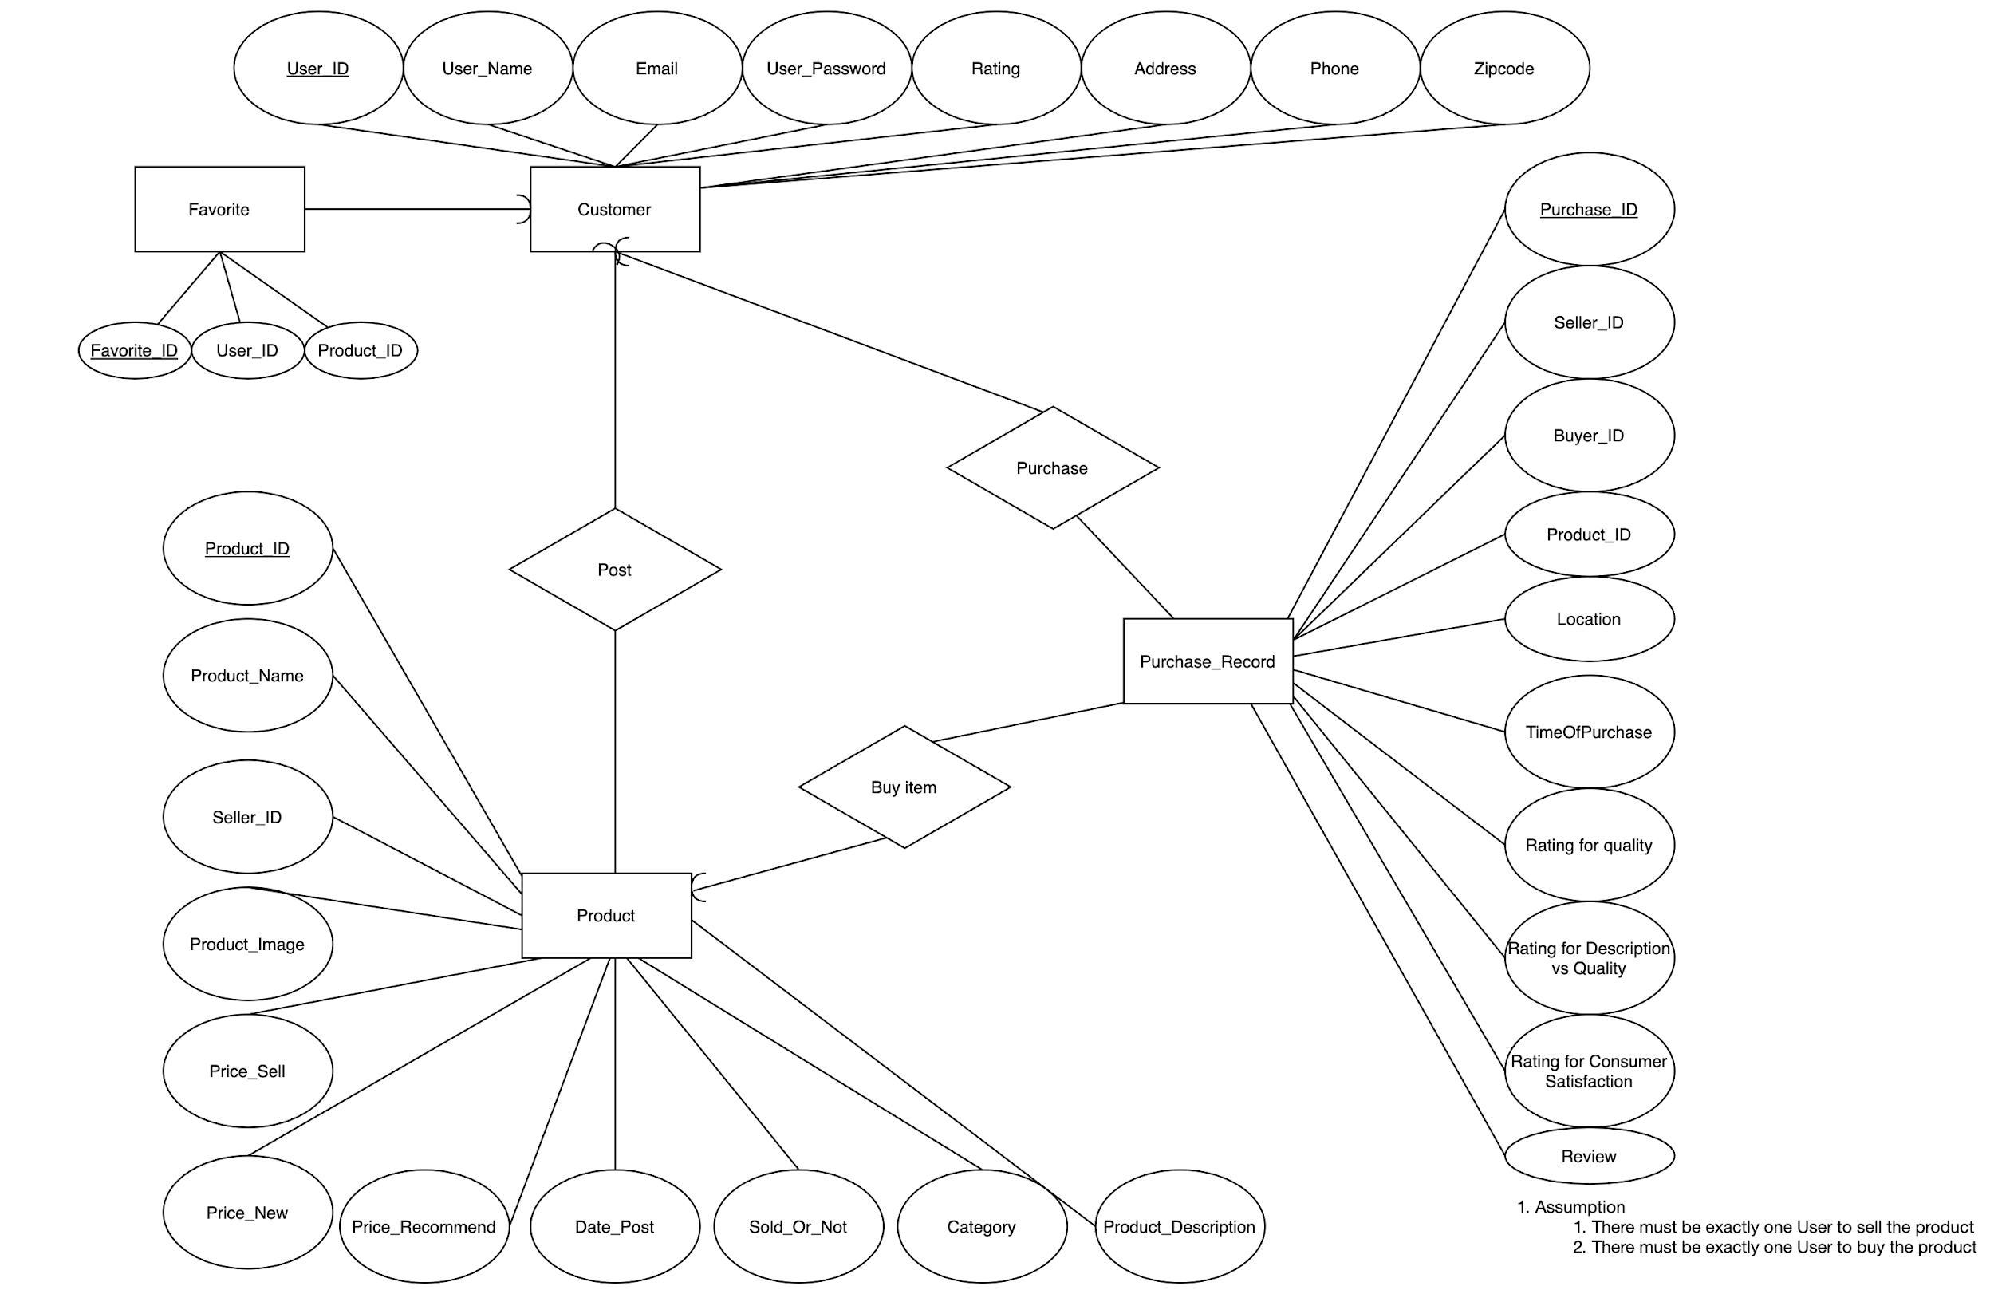
2. Briefly discuss from where you collected data and how you did it (if crawling is automated, explain how and what tools were used)
3. Clearly list the functionality of your application (feature specs)
   1. Our website aims to provide the basic functionality necessary to buy, sell, and exchange goods, as well as advance features, which could potentially solve the problems present in existing platforms, such as Facebook Marketplace.
   2. Basic functions:
      1. Adding an item to the database – every registered person will be able to add items they want to sell to our web site’s database.
      2. Delete an item from the database – every registered person will be able to delete items they wanted to sell to our web site’s database.
      3. Update an item from the database – every registered person will be able to update items they want to sell to our web site’s database.
      4. Searching item – every user will be able to search for items based on the keywords.
      5. Selecting item and contacting seller – once a user selects a particular item, he/she will be able to contact the seller about this item by email.
   3. Advanced functions:
      1. Website Authorization - every user will be able to sign up to our website using their Illinois.edu e-mail. This will verify their personality and ensure safety for other users.
      2. Sellers rating – in order to increase the quality of service, we are planning to implement the complex assessment of seller and its services based on several categories, such as:
         1. The general quality of the item
         2. How Description aligns with Reality
         3. Customer satisfaction rating (Attitude of the seller)
      3. Recommended trading location – as it was mentioned before, in the large platforms, such as Facebook, there exists a possibility of fraud and chance of getting robbed while exchanging/purchasing the product. In order to ensure safety of our clients, we want to add the feature which will list the safe places at campus, where people could exchange goods. They will have to select the place, and it will be saved in our website. In case if an incident happens, we will have the information where these people agreed to meet.
4. Explain one basic function

One of the basic functions we can do on our website is adding a new user through sign up page into our Customer table. Below is a part of the code from file “signup.inc.php” which allows us to Insert New User information such as user name, email address, password, zip code into the database. We used the prepared statements method for running our queries on the database this allows us to prevent the users from running any harmful queries on our database. In the first part of code we check if the username has already been taken or not in case the user name is already taken we prevent the user to register, in case the username is available we allow the user to register and run the query for inserting the new user information.

|  |
| --- |
| $sql = "SELECT User_Name FROM Customer WHERE User_Name=?";  $stmt = mysqli_stmt_init($conn);  if (!mysqli_stmt_prepare($stmt, $sql)) {  header("Location: ../signup.php?error=sqlerror");  exit();  }  else{  mysqli_stmt_bind_param($stmt, "s", $username);  mysqli_stmt_execute($stmt);  mysqli_stmt_store_result($stmt);  $resultCheck = mysqli_stmt_num_rows($stmt);  if ($resultCheck > 0) {  header("Location: ../signup.php?error=usertaken&mail=".$email);  exit();  }  else{   $sql = "INSERT INTO Customer (User_Name, Email, Phone, Zipcode, User_Password) VALUES(?, ?, ?, ?, ?)";  $stmt = mysqli_stmt_init($conn);  if (!mysqli_stmt_prepare($stmt, $sql)) {  header("Location: ../signup.php?error=sqlerror");  exit();  }  else{   *// $hashedPwd = password_hash($password, PASSWORD_DEFAULT);*   mysqli_stmt_bind_param($stmt, "sssss", $username, $email, $phone, $zip, $password);  mysqli_stmt_execute($stmt);  header("Location: ../signup.php?signup=success");  exit();  }  }   } |

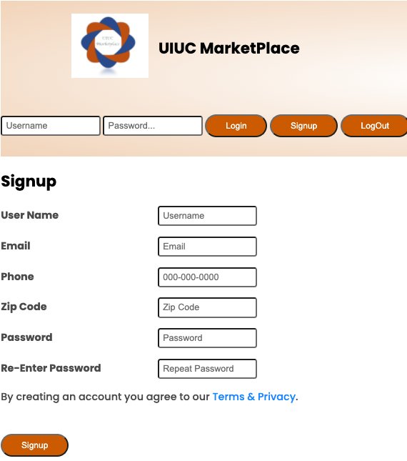

1. Show the actual SQL code snippet
   1. Add, update, delete a product:
      1. 
      2. 
      3. 
   2. Get the top seller, generous sellers among all users:
      1. 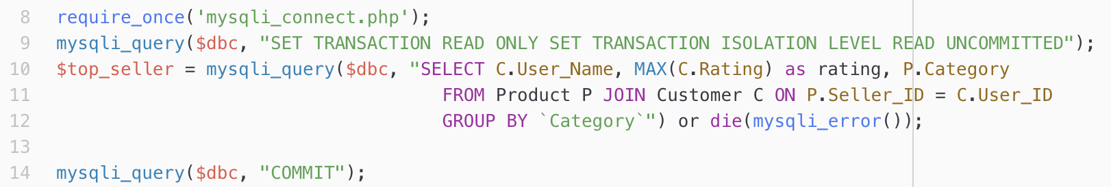
      2. 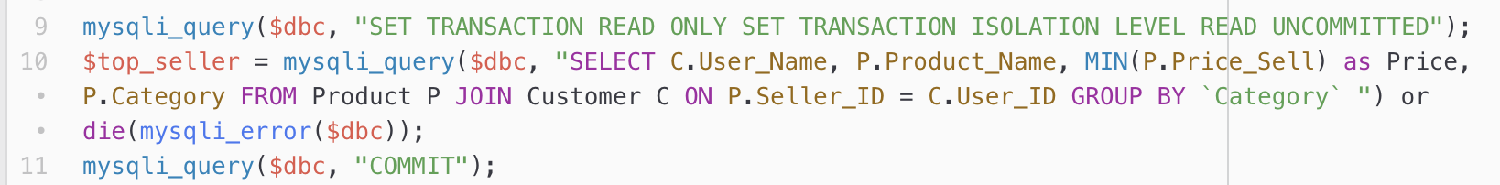
   3. Search based on the keyword, minPrice and maxPrice among all products:
      1. 
   4. Search with result sorted by distances:
      1. 
      2. 
2. List and briefly explain the dataflow, i.e. the steps that occur between a user entering the data on the screen and the output that occurs (you can insert a set of screenshots)

Search Function:

We can search for products on website using keywords in the search bar:



We can put a cap on the max price of the products and min price of products that we search:

We can look for products in separate categories:

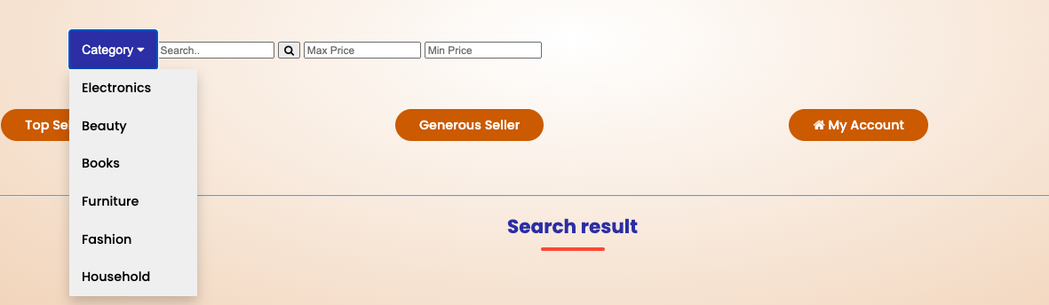

Sorting by Price:

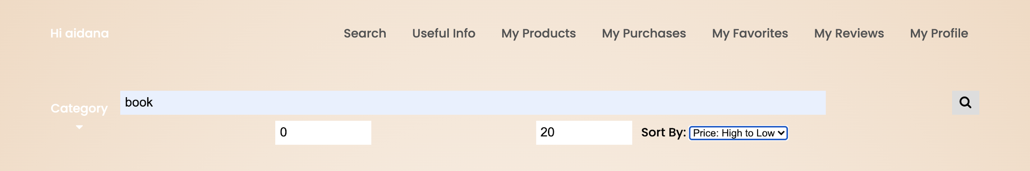

Sorting by Location:

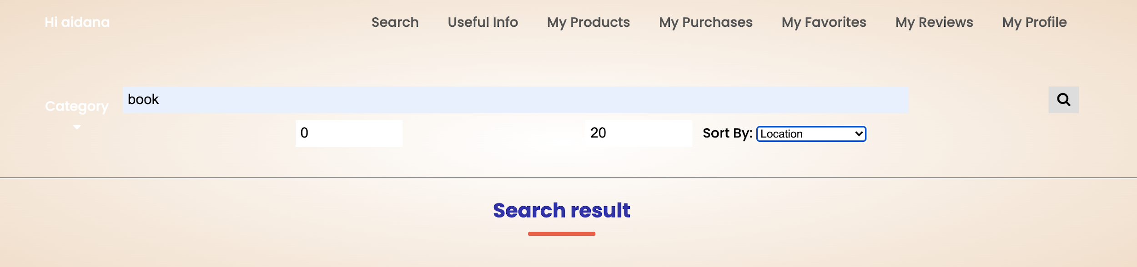

Search results for searching the book sorted by Location: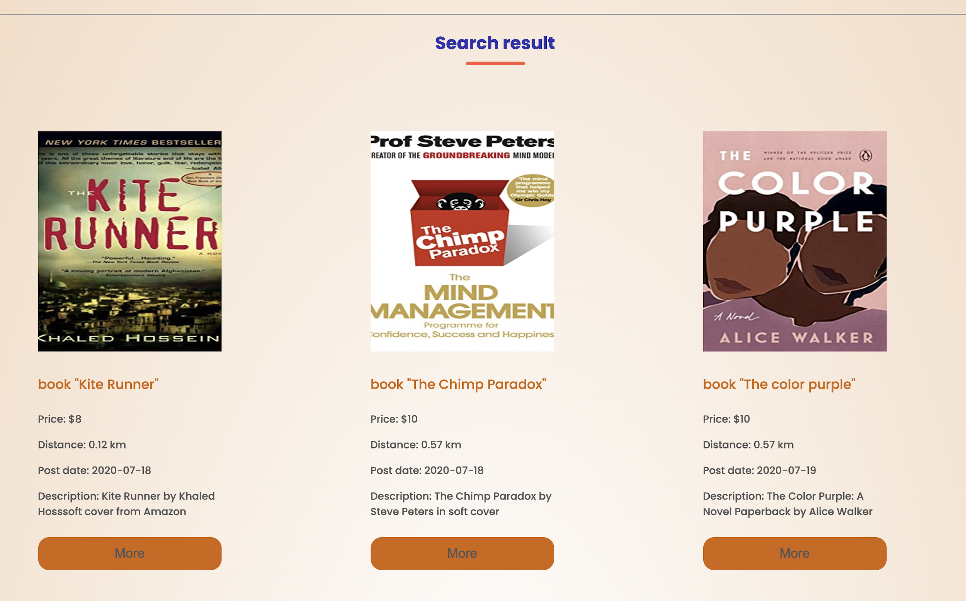

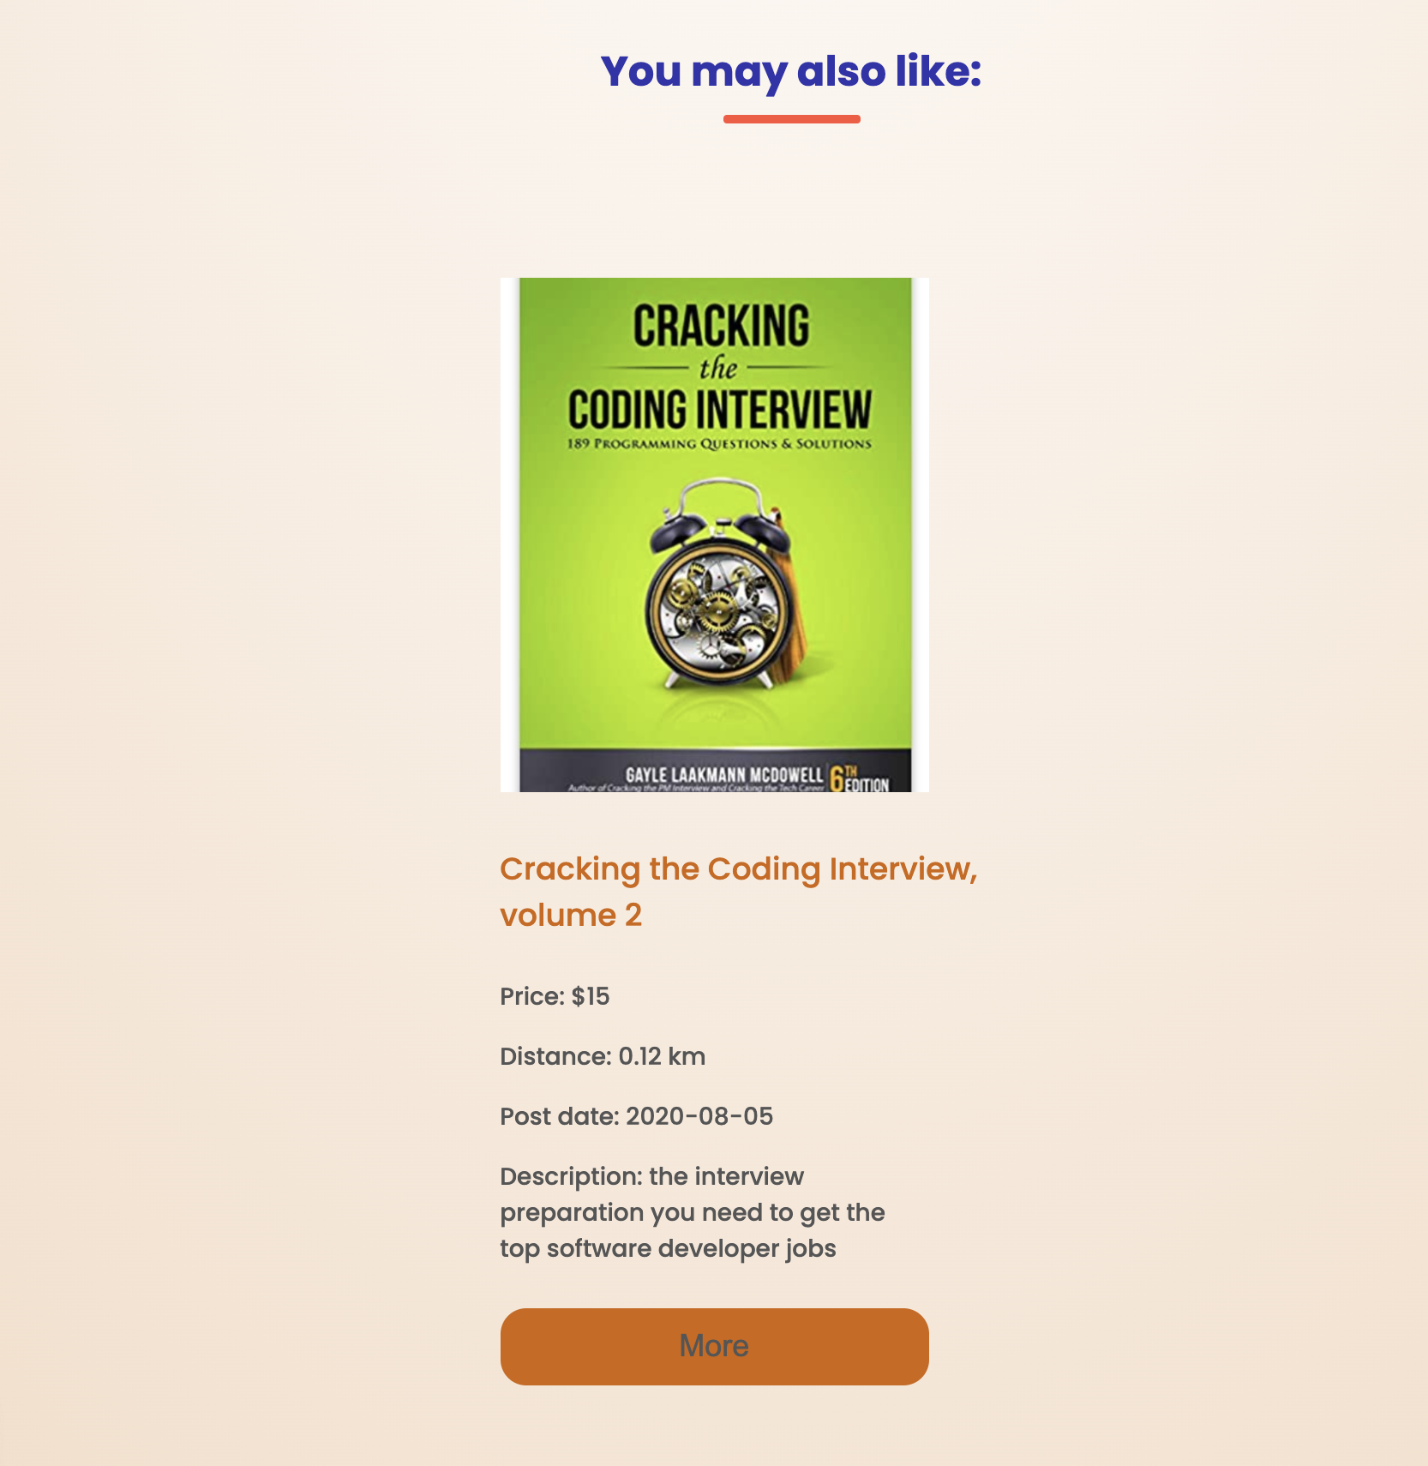Once we click on a product, we can see the detailed description and can either add it to our favorites page or proceed for buying:

If we are the owner of the listed product, we can edit the price and description anytime or remove it from the database.

1. **Explain your advanced function and why it is considered advanced**. Being able to do it is very important both in the report and final presentation.

Our first advance function is the sorting by the distance feature. It was implemented using the Google Maps API. When users are registering to our website, they are asked to provide their address and zip code. Then, based on this input, the coordinates of every user are parsed using Google Maps, so that every user has their location information. When the user is searching for the product, the results also contain the distance information, which is calculated by measuring the Euclidean distance between the buyer and each seller coordinates. After it, the user could sort the products by the distance to the seller.

Another advanced function is the Smart Search. Initially, we were thinking about using the PHP-NLP library, creating word embeddings, and then get the synonyms for the search input word based on the cosine similarity. However, due to several technical difficulties, namely, some of the python libraries were not compatible with server’s versions, we decided to use another approach. Given the input word or phase, we retrieved the synonyms for this word using the Thesaurus, and then we processed the output using regular expressions. If there were more than five synonyms, we used only the most popular five. After that, the query which is matching the product name or product description with every synonym was created, and results were presented in the section called “You may also like”. For example, if the user was searching for the desk, the computer table will appear in this section, since the words “desk” and “table” are synonyms.

We also added the transaction isolation level for the search page, for updating the product, deleting the product, for top seller and generous seller pages. For the search page, we used ‘Read only transaction’ with ‘Read Committed’ isolation level, so that users can search only for committed results. For updating the product, we used the ‘Read Write’ transaction with ‘Read Committed’ isolation level, so that read locks are released immediately after the read and exclusive locks are held by the end of the transaction.

For deleting the product, we used ‘Read Write’ transaction with ‘Repeatable Read’ isolation level, so that shared and exclusive locks are held by the end of the transaction. For the top seller and generous pages, we used ‘Read only’ transaction levels with ‘Read uncommitted’ isolation level, as they used only for statistics.

1. **Describe one technical challenge that the team encountered**. This should be sufficiently detailed such that another future team could use this as helpful advice if they were to start a similar project or where to maintain your project. **Say you created a very robust crawler - share your knowledge. You learned how to visualize a graph and make an interactive interface for it - teach all! Know how to minimize time building a mobile app - describe!**

Our team was thinking about using the B+ tree as one of our advanced functions, in order to improve the complexity of our search function. We implemented a B+ tree data structure that supports adding and deleting key-value pairs and searching for the value given the key in our back-end. Then, we added the data to the tree from our SQL product table using unique product numbers as a key. These keys are automatically assigned to products when they are added to the database. Before in our standard SQL search, users were searching for the name of the product, and then our query outputted all the products which contained that string. But after creating a B+ tree, the user should have been having a product key in order to search for it in the tree, however, the only way to retrieve the product key given the name of the product is again using the SQL query. We realized that our B+ -tree will not improve the complexity of our search in this case. We also understood that the B+ tree/hashing is already implemented on the system level of the DBMS. That was our technical difficulty with the B+ tree.

1. State if everything went according to the initial development plan and proposed specifications, if not - why?!
   1. Not everything went according to plan.
   2. Database:
      1. In the initial development plan, we have three tables in the database: Customer, Product and Purchase_Record. With the development of the website, we realized that it would be useful and reasonable to add a table named “Favorite” to store the information of the products that users would want to buy.
2. **Describe the final division of labor and how did you manage teamwork.**

The division of labor can be broadly observed as follows:

Jianjia:

Jianjia took care of the initial setup of the server and database, developing the frontend style sheets for certain pages of the website, development of Product Page with all the functionalities including adding, updating and deleting a product. He also contributed towards combining the various updates and part of the website developed by other group members including the login system, search page and user account page.

Aidana:

Aidana developed My Profile page and wrote the Advanced Queries for generating the top seller and generous seller list from the database. She also worked on giving her inputs on the style, layout and formatting of the entire website including all its pages. Using her expertise in the area of NLP she helped develop the smart search functionality in our website, and also implemented the location feature.

Vardhan:

Vardhan developed the login and signup system of the website. He assisted in developing and integrating the frontend style of the landing page with the rest of the website. He worked on developing the database with sufficient user information and managing the version control through github. He also developed the frontend and backend of the Customer review system and rating of products on the website.

Alena:

Alena worked on the development of the search page and different categories of the products that were used for cataloguing the products. She also created the minimum and maximum price feature, designed for searching in a particular price range. She along with Aidana contributed towards the advanced query as well as the implementation of Advanced function including the smart search and testing the b+ trees data structure.

All the group members always participated in the scheduled group meetings to discuss updates, hurdles faced by them and to add inputs to each other’s work. Our equal efforts went towards writing the prior reports and this final report

1. Video: <https://www.youtube.com/watch?v=xhYztxNEti8&feature=youtu.be>
2. Link to the GitHub: <https://github.com/vardhandongre/CS411SU20-JAVA/tree/aidana>